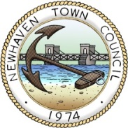

INVITATION TO TENDER – Turning the Tide

FOR PROFESSIONAL SERVICES TO ASSESS THE FEASIBILITY OF PROVIDING A ‘COMMUNITY/CREATIVE HUB’ AT 38 HIGH STREET, NEWHAVEN

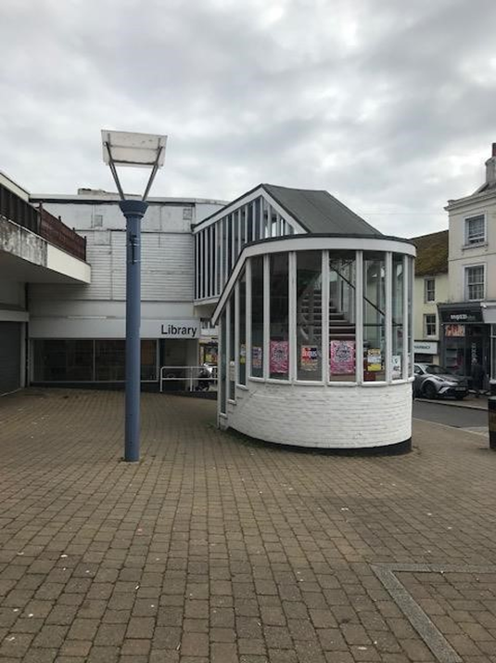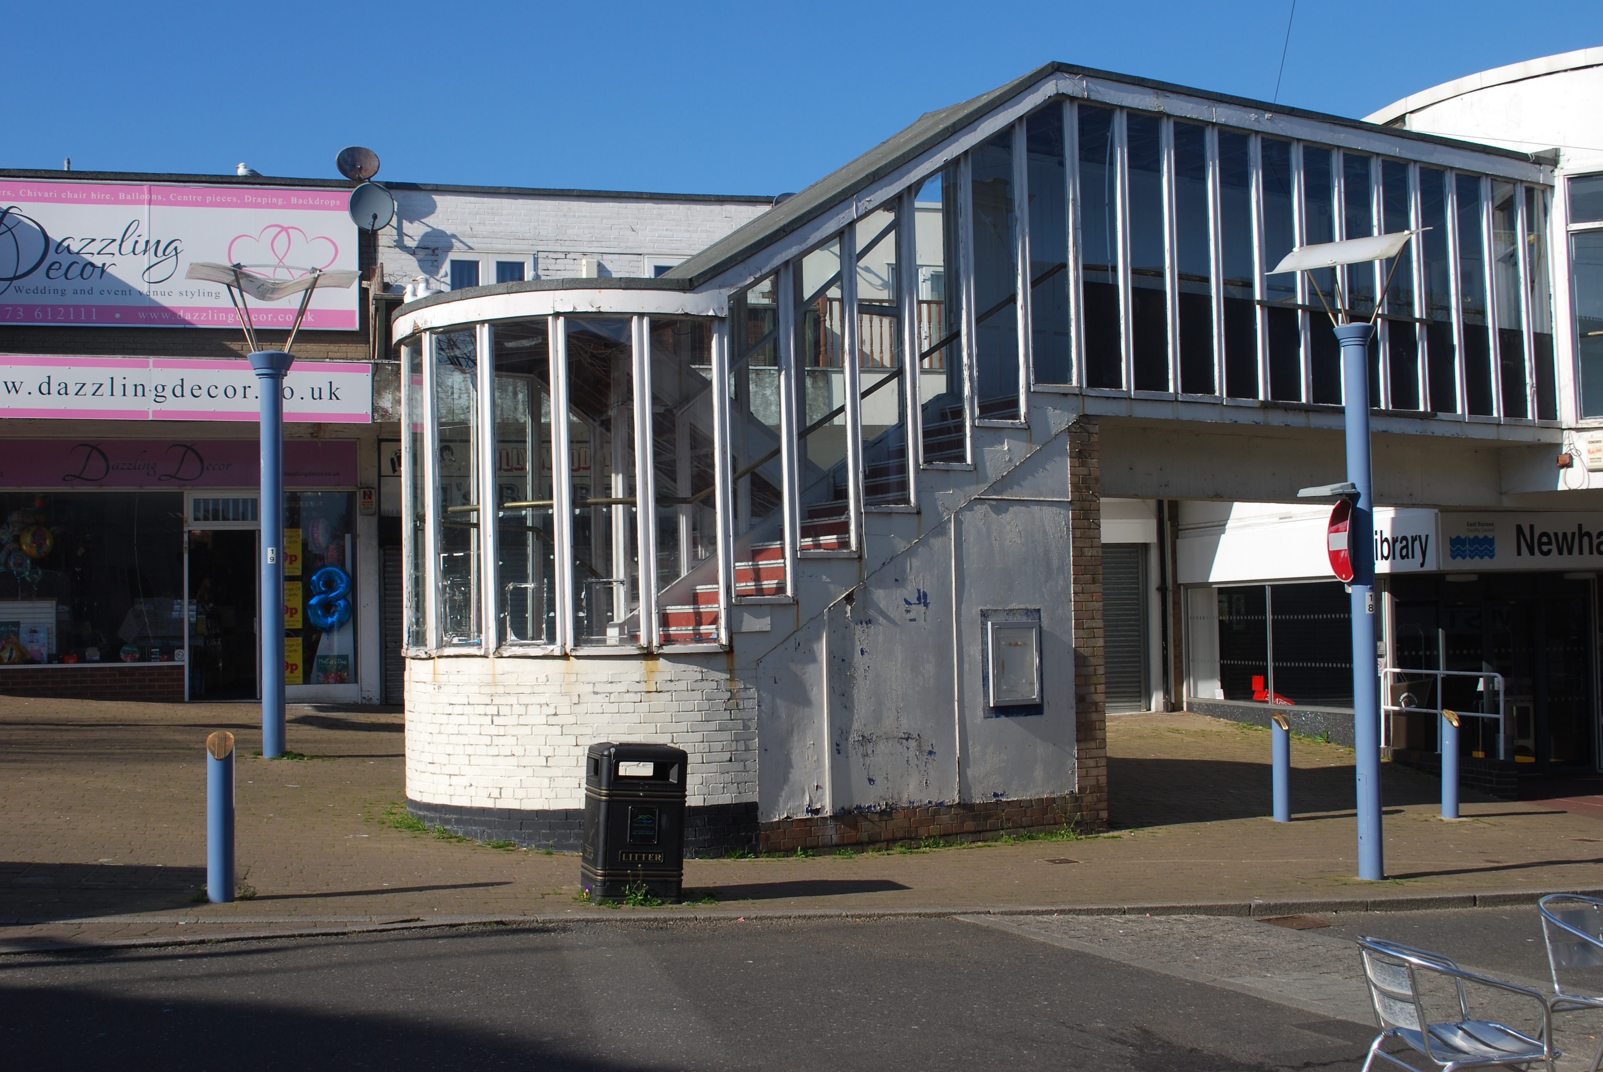

BRIEF OF WORK

November 2019

- Introduction

Newhaven Town Council is seeking to commission a feasibility study to consider the feasibility of setting up a Community/Creative Hub at 38 High Street, Newhaven, a first-floor premises above Newhaven Library. This first-floor space along with the Library at ground floor level, is owned by East Sussex County Council and is being offered as a lease arrangement.

As well as the assessing the practical suitability of the building for such a use – the availability of agency – the presence of a community of people who have a live and work in and around the hub, who feel that it is accessible and belongs to them will be integral to this piece of work.

It is these people that will give the building and the immediate area new vitality. Some may not want economic success for themselves or to make a business from their work, but their presence and activity will be enriching increasing vibrancy and quality of life in the town centre. This in turn will attract local people to the town, improve the offer for visitors, and residents will be able to feel a sense of well-being and a pride in their town. Therefore, identifying individuals and organisations that will champion such a use will be key to the success of the community hub.

- Newhaven in context

The town of Newhaven has a strong sense of identity which is visually enhanced by the background of the South Downs and the adjacent River Ouse and coast.
With a population of 13,000 it lies within the East Sussex coastal strip forming part of England's Creative Coast - stretching from Brighton 8 miles to the west, to Margate showcasing the South East's exceptional art and culture.

Currently a ‘Coastal Culture Trail’ links seventeen miles of beautiful East Sussex coastline via three award-winning contemporary art galleries, Towner in Eastbourne, the De La Warr Pavilion in Bexhill and the Jerwood Gallery in Hastings. To the north west is Ditchling Museum of Art and Craft.

The towns economic heritage lies in the maritime and manufacturing sectors and these continue to this day with the town forming the industrial heart of the Seahaven area. Today there are over 360 industrial and manufacturing businesses operating along the mouth of the River Ouse with manufacturing employing over 1,000 people locally.

In recent years the town has experienced some regeneration, but like other areas has been the victim of the economic downturn, with investment reducing and community facilities not keeping pace with aspirations and the growth in population.

These issues along with the reduction in public spending and private investment have put a strain on the town and in certain areas, this is particularly evident. The High Street has been subject to such a lack of investment and along with the changes in shopping habits, the town centre lacks vitality. Interestingly the retail offer has grown in the last 10 years with an increase in small independent shops, but the uses have not increased footfall and the character and public realm is of poor quality.

Despite these challenges, there is a strong sense of place and community in the town. Recent work by the Town Council has identified that the town attracts artists and makers, not least due to the relatively cheap land values, the town’s proximity to Brighton and the surrounding natural assets.

- Background: Relevant Policy and Studies

Newhaven has been subject to many studies and reports over recent years and these have been initiated from the three tiers of governance as well as partners and stakeholders. A small selection has been identified in this brief, due to their relevance as follows:

Physical Development Vision for Newhaven (2010)
In 2008, the consultancy BBP Regeneration were commissioned by Newhaven Strategic Network (NSN) to produce a 20-year physical development vision for the town of Newhaven. Partners included East Sussex County Council, Lewes District Council, Newhaven Town Council and Newhaven Community Development Association (now Sussex Community Development Association).

Actions for Creative Industries, Culture and IT in this document included:

- Involve the local community of artists and designers in plans to develop a creative quarter, to ensure that their specific requirements are catered for in the design and location of new workspace.
- Identify both existing accommodation and the potential to provide new accommodation, which will meet the needs of CCI businesses and encourage this sector to develop in the town.
- Promote links with universities and colleges to build a creative industries and education “hub” or join up with research and teaching.

Lewes District Core Strategy 2016 – 2030

Lewes District Council’s Core Strategy states that:
“Regeneration of the district’s coastal towns is a key objective of this plan. Key to this will be regeneration at Newhaven and growth will have a significant role to play in achieving this transformation. We need to work in partnership to deliver the regeneration of vacant, underused or poor-quality sites and premises and improve accessibility before allocating new green field sites for business development, particularly at Newhaven. We need to determine the best way of maintaining and enhancing the role of Newhaven as a regionally significant port with its associated facilities.”

Newhaven Enterprise Zone Strategic Framework 2018

The Strategic Framework sets out its vision for Quality Growth, Inclusive Growth and Sustainable Growth, which include aims to:

- Enable the local community to access funds to enhance the local area
- Grow the cultural economy in the town
- Develop the town centre to create a community hub with a strong retail and leisure offer
- Build on the legacy of the town and its vibrant community

Newhaven Coastal Community Team Economic Plan 2019

Off particular relevance to this project is the priority of ‘Profile and Ambition’ set out in the Economic Plan. Activities to meet this priority are set out in the table below with relevant activities highlighted:

Priority: Profile and Ambition

Activity | Lead Partners | S/M/L Term
The story of Newhaven  Undertake and produce a clear story/narrative for Newhaven which sets out where it has come from, where it is now and what are the ambitions/plans for the future. | CCT  Newhaven Town Council  Community | Short
Undertake a legibility study of Newhaven. To include:  New signage and welcome signs  Brown visitor signs and information boards  Review existing footpaths, street clutter, seating, pedestrian crossings, lighting, pedestrianisation, shared surfaces, cycle ways, walking routes around town, links to the National park. | Newhaven Town Council  Lewes District Council  East Sussex County Council | Short
Town Centre development  Local community working with the local authority and Town Council on a Future High Street Fund proposal for Newhaven Town Centre to realise the vision for an integrated, diversified and strengthened centre. | Lewes District Council  Newhaven Town Council  Local community | Short
Town centre Manager post  Investigate the possibility of recruiting a town centre manager for Newhaven. | Lewes District Council  Newhaven Town Council | Short-Medium
Pop-Up Shops  Design a pilot programme to support the creation of pop-up shops in the High Street in advance of major re-development plans for the town centre. | Lewes District Council  Chamber of Commerce  Newhaven Town Council  Local retailers | Short
Community Tourism  Build the capacity within the local community to identify and deliver community-run tourism projects and activities, e.g. walking routes, cycling trails etc | Local community  Newhaven Town Council | Short
Events and festivals  Develop a programme of events and festival to include ideas surrounding farmers market/regular annual events including preparing an Events Toolkit to support local communities organise events. | Local community  Newhaven Town Council  Lewes District Council | Short-Medium
Encourage new visitor accommodation provision  Consider sites and options for new hotels or other types of accommodation possibly focussing on sustainable providers/high end market provision. | Site owners  Hotel operators  Newhaven Town Council | Medium
Creation of new arts and craft centre in disused town centre building  Develop the town centre as an arts/crafts/heritage/food & drink centre. | Newhaven Town Council  Lewes Town Council  Arts Council England  Local community | Medium
Develop a Shop Frontage Improvement Programme  A scheme to assist shop owners, tenants and landlords to improve the external appearance of their premises. | Retail owners/shop owners  Newhaven Town Council | Short
Audit of public open spaces  A detailed assessment and audit of all parks and open spaces in Newhaven with a view of identifying gaps in provision or standard of facilities. | Lewes District Council  Newhaven Town Council | Short
Public Places Action Team  Teams of volunteers supported by local businesses that identify where public places need improvements/clean up/painting and improvement. Identify a public realm ‘pot’ – a list of improvements and provision to be used when funding is available and/or where sponsorship funds can be harnessed. | Local Community  Chamber of Commerce  Sussex Community Development Association  Newhaven Town Council | Short-Medium
Local Cultural and Heritage Action Plan  Action plan to consider options for museum/art gallery/cultural attraction for the town. | Lewes District Council  Arts Council England  East Sussex County Council | Short
Seafront/beach development strategy  To consider possible visitor options to visit the beach areas in Newhaven to link in with the England Coast Path and Castle Hill/Newhaven Fort as a destination. | Lewes District Council | Short
Destination Brand  Pride - harness civic pride and promote a positive identity for Newhaven by creating a brand identity to unify the town and inspire residents and visitors. To work with the Destination Action Group (see Partnership and Collaboration table) to develop a destination brand to be used by key authorities and agencies in promoting the town for tourism and business. | Lewes District Council  Newhaven Enterprise Zone  East Sussex County Council  Locate East Sussex | Medium

Newhaven Neighbourhood Plan 2019
Newhaven Town Council have prepared a Neighbourhood Plan for the town which has successfully been through the examination and referendum processes thereby complying with the Neighbourhood Plan (General) Regulations.

The Vision for Newhaven in the Plan, inter alia, states that by 2030;

The town will have a strong and diverse economic base which meets the employment needs of the local community and wider area, with its reputation as a hub for the ‘clean and green’ sector fully established. The town centre will provide an accessible focus to community life, revitalised with high quality public spaces and a greater range of uses and activity.

As well as setting out planning policies for the growth and development of Newhaven, the Neighbourhood Plan suggests actions to improve the towns environment. One such ‘quick win’ is to ‘Seek opportunities for redundant buildings to be reimagined for arts and cultural use’.

Ongoing Studies

Most recently, due in part to the location of the town centre forming part of the Newhaven Enterprise Zone, funding has been sourced from the Future High Streets Fund and Enterprise Zone Fund to carry out studies on options for regeneration and developing the narrative for the town. Studies on these pieces of work are emerging with information on these being available from Lewes District Council Regeneration Department.

- Scope of study

The ‘Turning the Tide’ project is to create a Community Hub and Arts centre at first floor level above Newhaven Library in the town centre. The centrally located space formally used as storage/office space, a church and nightclub, would be reimagined to provide a multi-purpose community facilities/services such as: Town Council Offices, a community café, gallery/quality performance space, artists and makers studio space.

Community buildings are multi-purpose and accessible to residents. They can provide community services, delivered by community members and are often managed by a dedicated community organisation. Such ‘hubs’ should be responsive to changing needs and demands within the community and a common enabler of success is the importance of maintaining a focus on the specific needs of the community they serve.

Community hubs need an income to be sustainable and ensure they will be there in years to come. A range of income sources is usually required to cover all of the costs for looking after the building, and running the activities, e.g. grants, donations, hiring out space, delivering contracts, etc. Effective community hubs make use of good ideas and resources within the community and are able to adapt to changing circumstances.

When the emphasis is on a Creative Hub, there is an assumption that the space will include bringing creative people together, providing space and support for networking, business development and community engagement within the creative, cultural and technological sectors.

There is overlap in the offer that a Community Hub or Cultural Hub can bring to a High Street area. Such uses can include a range of some of the suggestions below, though these do not preclude other uses that are of community benefit.

- Community hall or meeting space
- Health or well-being activities
- Office or workspace for local community/voluntary groups
- Other arts or cultural activities
- Sports or fitness activities
- Educational activities
- Advice and support for other community/voluntary groups
- Skills and employment training
- Community café
- Office or workspace for local public sector agencies
- Community festival
- Heritage activities
- Office or workspace for local private sector companies
- Online/digital services
- Workshop or makerspace
- Community cinema, gallery or theatre

- Outputs

The Feasibility Study will:

- Review the suitability of the 1st Floor of the Library (including accessibility) for use as a community/cultural hub
- Identify potential target groups/users in the community; audiences, potential partners; stakeholders and identify how this project compliments existing provision in the area
- Identify potential specific offers, mindful of:
- Community benefit
- refurbishment costs reflective of the offer
- revenue generation
- existing and latent demand in relevant sectors including creative, cultural, technology, social enterprise
- synergy with library offer on ground floor
- Identify what synergistic activities/services could the hub provide E.g. studio rental, hot desking, networking, events, café, health and business support
- Identify what is needed to make the hub a reality E.g. types of resources, finance, equipment and staff
- Draw up a high-level business plan that will recommend a governance structure, identifying how the centre could be commercially viable and sustainable once it is operational.
- Establish timeline for implementation

- Key Stakeholders and Beneficiaries

Key Stakeholders:

Arts Council
East Sussex County Council
Lewes District Council
Newhaven Enterprise Zone
Newhaven Chamber of Commerce
Creative Sector

Beneficiaries

The local community though direct and indirect opportunities and improvements such as access to the community hub and the leisure, cultural and networking uses provided and improved image and public realm improvements, the library service through co-location, local traders through additional footfall in the town centre. Potentially the creative cluster through opportunities for networking, entrepreneurship and enterprise.

- Timetabling

Stage | Action | Timing | Comment
Stage 1 | Invitation to Tender | 27th November 2019
Stage 2 | Tender submission deadline | 16th December 2019
Stage 3 | Award tender | 20th December 2019 | Working Group to consider and award
Stage 4 | Inception Meeting | W/C 6th January 2020 | With working group
Stage 5 | Draft expected | W/C 10th February 2020 | Working Group to review and comment
Stage 6 | Final version approved | W/C 24th February | Approved subject to comments above
Stage 6 | Extraordinary Full Council Meeting | March 2020 | Calling of meeting will be dependent on study findings

- Fee

Funding towards this study has been sourced from the Arts Council. Submission document can be found at Appendix 1.

It is expected that this commission would cost in the region of £10,000.00.

- Submission Instructions

Proposals are invited to the contracting authority Newhaven Town Council and should be sent to Susie.mullins@newhaventowncouncil.gov.uk by 17.00 on 16th December 2019. Any queries regarding the tender process should also be addressed to this contact.

Proposals should include for a minimum:
- Tender submission
- CV of consultant and any associates likely to be involved
- Total fixed cost - to include on the tender response form at Appendix 2 an indication of days/%days to be dedicated to the work and by whom.
- Details of two previous clients who can be contacted for references

- Contract Award

The Town Council reserves the right to amend the timetable at its absolute discretion at any time during the tendering process. The Town Council does not undertake to accept any tender and all participants will be notified simultaneously about any award.

- Audience

It is anticipated that the audience for this piece of work will be the Arts Council, East Sussex County Council (as land owners), Lewes District Council, Enterprise Zone Board, Coastal Community Team, South East Local Enterprise Partnership, funding providers, community groups and businesses in the creative and digital sector.

This document will assist in highlighting the evidence needed to attract investment and funding.

- Reference Documents

Relevant reference documents are set out below and can be found on organisations websites as indicated.

Document | Access
Lewes District Council Joint Core Strategy | www.lewes-eastbourne.gov.uk
Lewes District Council Local Plan Part 2 – Pre-submission document | www.lewes-eastbourne.gov.uk
Newhaven Enterprise Zone Strategic Framework | www.lewes-eastbourne.gov.uk
Newhaven Neighbourhood Plan | www.newhaventowncouncil.gov.uk
Newhaven CCT Economic Plan 2019  South East Creative Economy Network Prospectus | To be provided  https://www.eastsussex.gov.uk/business/eastsussex/selep/secen/

- Assessment Criteria

Appreciation and understanding of the brief | 60%
Value for money | 20%
Experience and references | 20%

- Project Contact

Susie Mullins
Newhaven Town Council
18 Fort Road,
Newhaven BN9 9QT
Susie.mullins@newhaventowncouncil.gov.uk 01273 516100

- Additional Information

Freedom of Information Act 2000

The Freedom of Information Act (FOIA) came into force on 1st January 2005 and established a general right of access to all types of 'recorded' information, including public contracts and procurement activity held by the Council, subject to certain conditions and exemptions. Accordingly, all information submitted may need to be disclosed in response to a request under the Act.

This means that the Council is obliged under the Act to release certain information about its suppliers into the public domain within certain limits and according to relevant exemptions. The main exemption relevant to procurement is commercial interests, which means trade secrets and information likely to prejudice the commercial interests of any person (including the Council) holding it.
If you consider that any of the information in your tender is commercially sensitive, please explain (in broad terms) what harm may result from disclosure if a request is received, and the time period applicable to that sensitivity. You should also be aware that, even where you have indicated that information is commercially sensitive, the Council may be required to disclose it under the Act if a request is received. Please also note that the receipt of any material marked "confidential" or equivalent by the Council should not be taken to mean that we accept any duty of confidence by virtue of the marking.

If a request is received, the Council may also be required to disclose details of unsuccessful tenders.

Government Transparency Policy

The policy of central government is that all local authorities should be completely transparent about what they spend taxpayers’ money on and who that money is spent with. Therefore, you should be aware that if you are successful in obtaining this contract, details of all payments will be reported to Full Council and be reproduced on the Town Council’s website.

Appendix 1 Project Outcomes – Copy of application for Arts Council Funding

Turning the Tide - Project Outcomes

Consider Objectives | Summary | Measure | Partner
Community Café/Networking Space building community reliance and connections | Will bring people together and support networks. Can provide early intervention services and safe spaces. Can provide a holistic environment. Develop volunteering. | Use of community space, income of space,  Strengthened partnership working | NTC  NCIC
Relocated Newhaven Town Council Offices | Relocate Town Council office to central location in town centre |  | NTC  ESCC
Gallery/Performance Space/Exhibition Space/Special Event Space building partnership and collaboration | Exemplar facilities galvanising bottom up regeneration. Promoting relationships with organisations (Ditchling Museum, Brighton offers, Towner, De La Warr and Jerwood). Income stream. | Income of space,  Events programme  Clear offer to tourism and visitors | NTC  NCIC
Artist/Makers Studios providing employment and developing skills | Responding to identified need by providing work space to creative sector. Potential to develop links with education and training providers. Supporting entrepreneurial ambitions. Income stream. | Jobs Created,  income | NTC  NCIC  LDC
Representative of local creative cluster and improved self image building profile and ambition | Will transform an underused and neglected building in a central location, to have multi-purpose uses. Base to develop local projects as well as projects with a broader reach. Promoting creative cluster important to regeneration. Build on creative heritage of the town. | Visitor and Tourism offer | NTC  LDC  NCIC
Project sustainability | Project will use a local asset therefore sustainability at its heart. Will need a range of incomes to be sustainable. Income sources required to cover the costs of running the building and any activities. Income delivered through rent of work spaces/hiring out space, funding, donations. Build in flexibility to management scheme to ensure ability to react to potential funding streams, while keeping the integrity of the project. | Expenses offset by income/funding streams | NTC

Appendix 2 - TENDER RESPONSE FORM

CONSULTANT’S NAME………………………………………………………………………………

CONSULTANT’S ADDRESS…………………………………………………………………………

………………………………………………………………………………………

CONTACT NAME………………………………………………………………………………..........

PHONE No ……………………….

EMAIL ADDRESS ……………………………………………..

Fixed price fees for undertaking the services detailed in Paragraph 5, including any disbursements, but excluding VAT.

total cost £………………………………

Rates:

Staff | Name | Day rate £
Senior/Director/Partner
Professional
Assistant grade/technician

Proposed outline of your initial proposals to demonstrate your
understanding of the brief and your approach
to meet the scope and outputs of the brief attached? YES / NO
Proposed project team details CV attached? YES / NO

Electronic copy attached? YES / NO

Hard Copy sent? YES / NO

Signed ……………………………………….… Position …………………………

Print Name …………………………………… Date ……………………………

