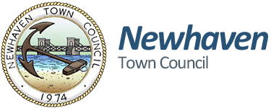
Newhaven Business Directory – Listing Form
The aim of the directory is to make Newhaven residents aware of the businesses that are available in the local area. Encouraging residents and visitors to use local businesses will add to the vitality and success of our community.
For inclusion onto the Business Directory please complete and return this form to susie.mullins@newhaventowncouncil.gov.uk or for information telephone Newhaven Town Council on 01273 516100

Business Name……………………………………………………………………………………………….
Business Address……………………………………………………………………………………………………………
………………………………………………………………………………………………………………………..
Work Phone……………………………………………………………………………………………………..
Mobile Phone…………………………………………………………………………………………………..
Website……………………………………………………………………………………………………………
Email………………………………………………………………………………………………………………..
Description of Business

Newhaven Town Council will comply with data protection law. This says that the personal data we hold about you must be: • Used lawfully, fairly and in a transparent way. • Collected only for valid purposes that we have clearly explained to you and not used in any way that is incompatible with those purposes. • Relevant to the purposes we have told you about and limited only to those purposes. • Accurate and kept up to date. • Kept only as long as necessary for the purposes we have told you about. • Kept and destroyed securely including ensuring that appropriate technical and security measures are in place to protect your personal data to protect personal data from loss, misuse, unauthorised access and disclosure.

