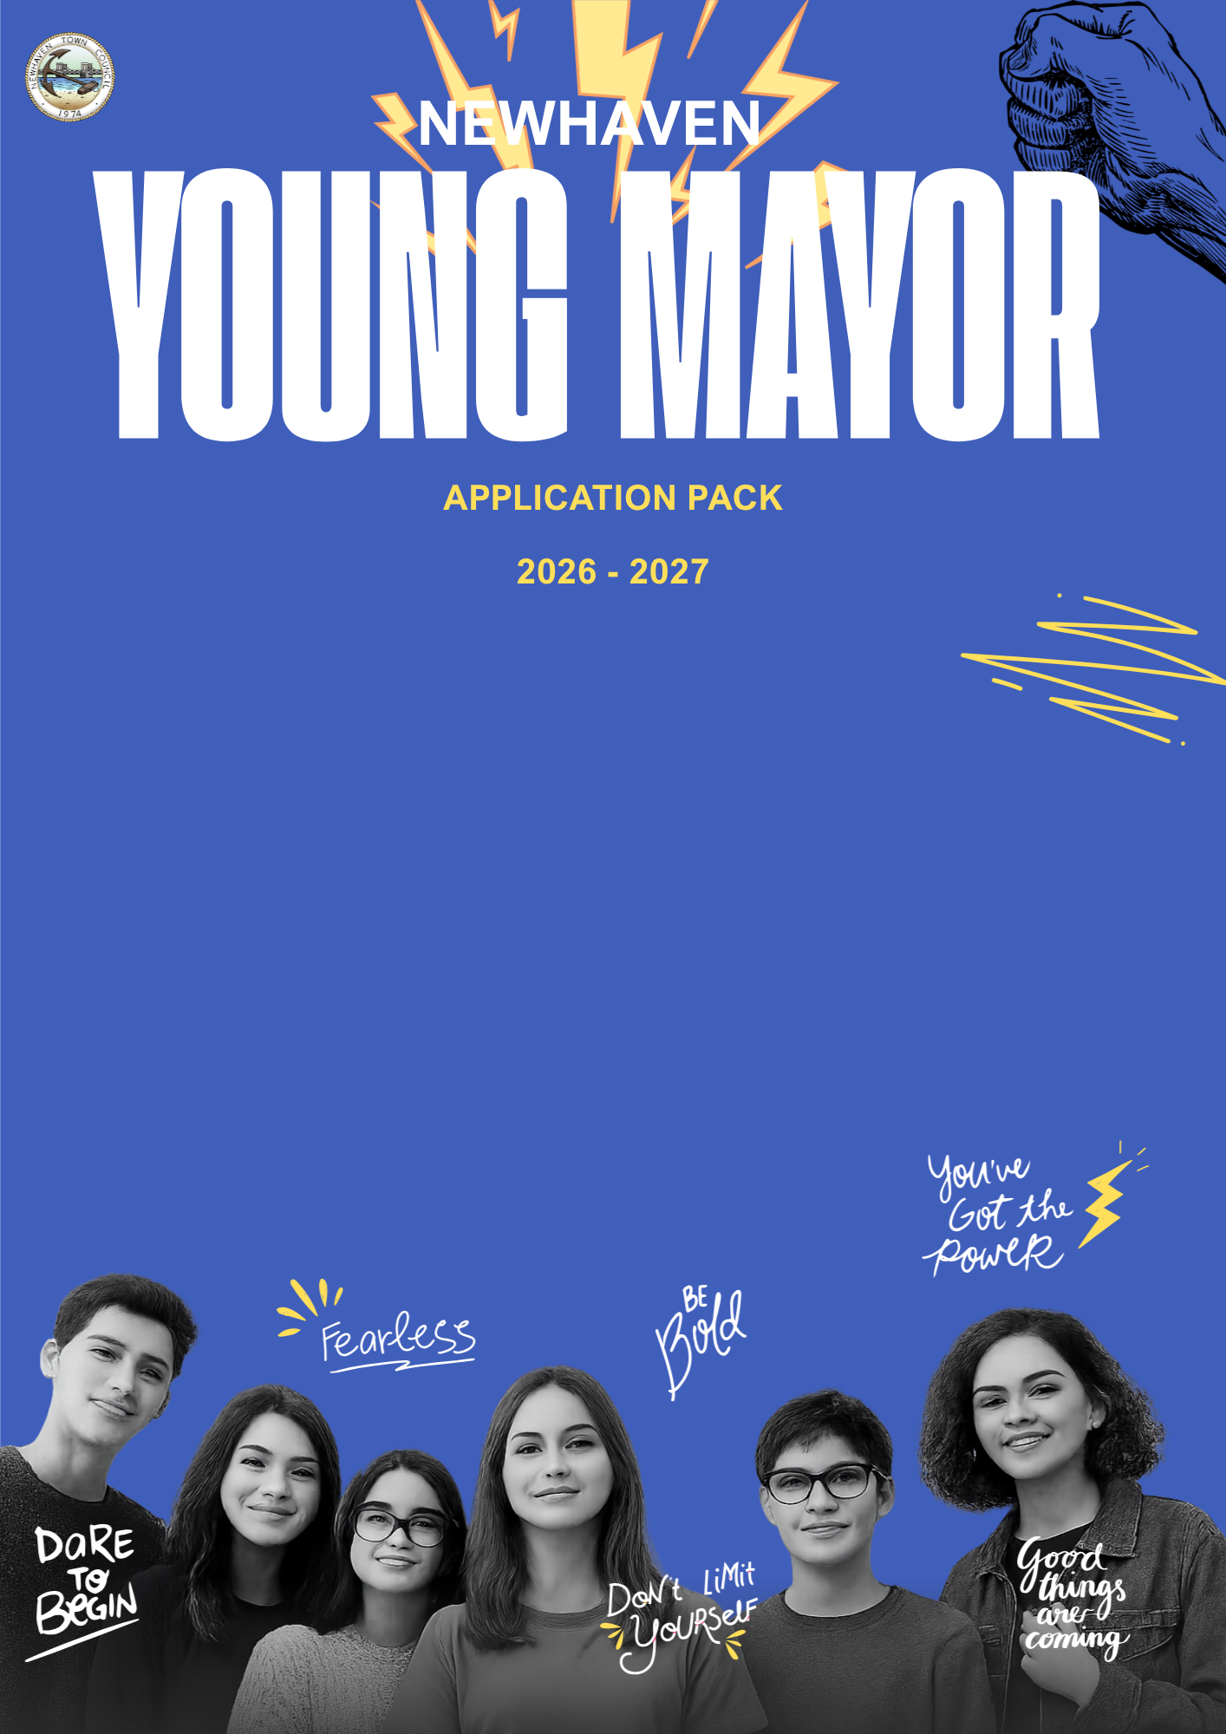

Introduction 2
6 Steps to Being a Successful Candidate 3
Young Mayor Candidate Application Form 4
Parental/Guardian’s Consent Form 6
The Ideal Presentation 7


Introduction

Thank you for showing an interest. It is with great pleasure that we enclose the forms you need to complete to apply for Newhaven Young Mayor. Please use the checkboxes below to help you complete your application:

☐ 6 steps to being a successful candidate.
☐ A Young Mayor Application Form that you need to complete.
☐A Parental/Guardian Consent Form which one of your parents or guardians needs to complete.
☐A Medical Form your parent/guardian needs to complete.
☐ A Presentation draft that you need to complete.
☐Send your application

You can submit your completed candidate form as soon as you have completed it (you don’t have to leave it until the last minute!) Send an email with a scanned copy of your completed candidate form to us at: admin@newhaventowncouncil.gov.uk.
If this is not possible then contact us to arrange to pick up/drop off. We can pick up from school or ask a teacher to scan and email it for you.

The deadline for us to receive your completed candidate form is 5pm on 30th April 2026. If we don’t receive your form by the deadline, you won’t be able to stand in the election.

Any questions?
Call or email us (details below) and we’ll help you. There is also more information about what previous Young Mayors have done at www.newhaventowncouncil.gov.uk/young-mayor.
Call: 01273 516100
Email: admin@newhaventowncouncil.gov.uk

Good luck! And we look forward to receiving your forms.

6 steps to being a successful candidate


This is an easy guide to make sure you can become a successful applicant for this year’s Young Mayor of Newhaven.
STEP 1. If you meet the criteria below, you may apply for Young Mayor:
Criteria 1: Are you going to be aged between 13 and 17 years old on 19th May 2026?
Criteria 2: Do you live, work or go to school/college in Newhaven?
STEP 2: Read and complete the Young Mayor Candidate Application Form. Don’t forget to sign the declaration.
STEP 3: Give the Parental/Guardian’s Consent Form to your responsible adult. They must give the form back to you when they’ve completed it. Please scan (if you can’t scan, then get in touch) and email the completed form to us by 30th April 2026.
STEP 4: Write Your Presentation. This will explain why you want to become Newhaven’s Young Mayor. It doesn’t have to be perfect right now. You have up until 19th May to perfect what you are going to say. What would make Newhaven a better place for young people? What do young people in Newhaven want? Do you have a charity you feel passionate about that you would like to support? Talk about it in this section!
STEP 5: Double check you have filled everything in
Don’t forget that you can contact us (all the details are at the bottom of the page) if you have any questions about any of this. No question is too silly so don’t feel embarrassed!
STEP 6: Start thinking ahead
We will contact you to let you know you have been put on the applicants list, then you will need to begin practicing your presentation for the Full Council Meeting on 19th May. We will be in contact with you confirming the time and date after applications close.

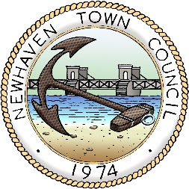
Young Mayor Candidate Application Form

My name is: ________________________________________________ and I am applying for Young Mayor of Newhaven.

My date of birth is: _______________________

I confirm that:
(Tick boxes as appropriate)
☐I am between the ages of 13 and 17 on 19th May 2026
☐I live, work or attend school/college in the Newhaven

School/College___________________________________________________________________________

Place of work_____________________________________________________________________________________

My contact details:
Home telephone number: ___________________________________________________________________

Mobile phone number: _________________________________________________________________________

Email address: ___________________________________________________________________________

My address is: __________________________________________________________________________

_________________________________________________________________________________________

Candidate declaration
I DECLARE THAT THE INFORMATION THAT I HAVE GIVEN ON THIS FORM IS TRUE AND THAT I MEET THE CONDITIONS FOR BEING YOUNG MAYOR OF NEWHAVEN.

SIGNED: DATE:

Parental/Guardian’s consent form

I have read the guidance and support the application of _________________________________ (name of candidate). I can confirm that this candidate is:

☐aged between 13–17 years
☐lives in the Newhaven OR
☐is educated or goes to school in the Newhaven OR
☐works in Newhaven.

I provide my consent for the above-named child to stand as a candidate for the 2026 Young Mayor of Newhaven. I provide consent that photographs and video may be taken of the child named above and may be used in current and future council publications (both print and online - including social media). I am aware that the child I am responsible for may be asked to join a WhatsApp group for communications with the Communications and Events Officer at Newhaven Town Council and that I can request access to view these communicationa at any time.
Please complete:
Full name: ______________________________________________________________________________________________

Address: ________________________________________________________________________________________________

Daytime Contact Number: _______________________________________________________________________________

Evening Contact Number: ________________________________________________________________________________

Email: __________________________________________________________________________________________________

Signed: _________________________________________________________________________________________________
The Presentation
Your presentation needs to spell out ‘your reason to apply’ by explaining what things you would change or work on in Newhaven if you were appointed as Newhaven Young Mayor. You need to present this to the full council on 19th May.

It needs to answer the following:
- Why are you applying for Newhaven Young Mayor?
- What will you do for the young people of Newhaven. What do they want?
- Why are you the best person for the job?

It needs to be written in simple language and short, sharp sentences. Use examples and stories to explain why you are doing things (for example, you want a skate park because your neighbour got knocked over in the street as there was nowhere for them to skate).

Be creative but realistic. Don’t promise things you can’t do. Be honest about yourself. Is this all about you or the young people of Newhaven?

Be different – you need to stand out from the others.

Call or email us if you want help with this or want to run your final version by us first.

Now that you are done – please email to admin@newhaventowncouncil.gov.uk
Or visit our office at 18 Fort Road, Newhaven, East Sussex, BN9 9QE

