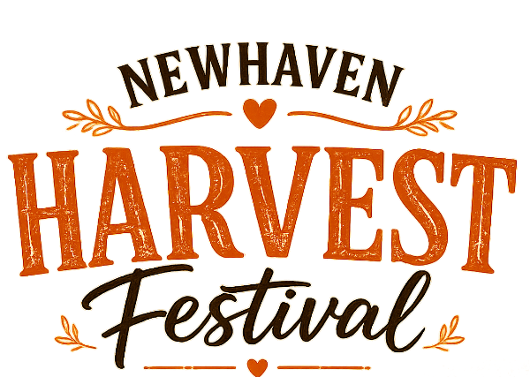

Newhaven Grower of the Year Application Form

Name:
Email:
Phone number:
Address:

Which vegetables are you bringing?

Competition Information
You may submit up to 3 vegetables or fruits but only win one category.
Under 18’s are welcome to enter the competition.
There will be several category awards. The best and ugliest vegetable winners will be awarded a £30 Paradise Park Voucher.
Winners will be announced at 3pm by the Mayor of Newhaven on 3rd October at the Harvest Festival, held in Newhaven High Street. Please bring your vegetable/fruit for 1:00pm when the festival begins. It will be put on display for voting. You will be welcome to take your vegetable/fruit back home with you afterwards, or donate it to Newhaven Food Bank.
If you have any further questions , please email events@newhaventowncouncil.gov.uk
Or you can Whatsapp or text the Event Coordinator on 07837300587

We wish you the best of luck!

-NTC Team

